Manage files with Linux commands
In this scenario, you need to ensure that the /home/analyst directory is properly organized.
You have to make a few changes to the /home/analyst directory and the files it contains.
You also have to edit a file to record the changes or updates you make to the directory.
When you start, the /home/analyst directory contains the following subdirectories and files:
Task 1. Create a new directory
Task 2. Remove a directory
Task 3. Move a file
Task 4. Remove a file
Task 5. Create a new file
Task 6. Edit a file

First, you must create a dedicated subdirectory called logs, which will be used to store all future log files.
- Create a new subdirectory called logs in the /home/analyst directory.
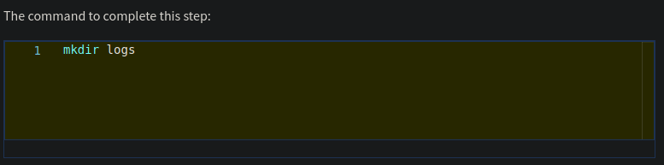
2. List the contents of the /home/analyst directory to confirm that you’ve successfully created the new logs subdirectory.
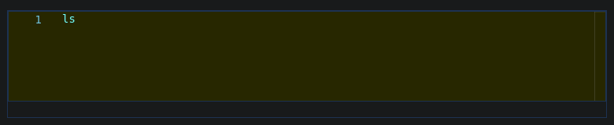
The command to complete this step:
The output should list the original three directories and the new logs subdirectory:
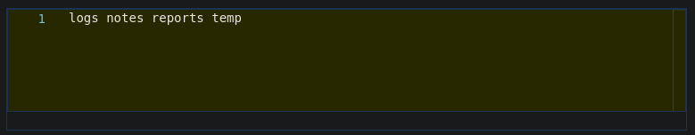
Task 2. Remove a directory
Next, you must remove the temp directory, as you’ll no longer be placing items in it.
- Remove the /home/analyst/temp directory.
The command to complete this step:
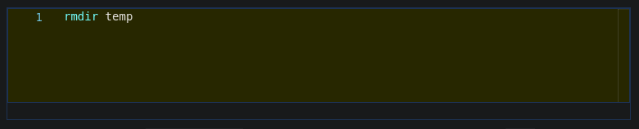
2. List the contents of the /home/analyst directory to confirm that you have removed the temp subdirectory.
The command to complete this step:
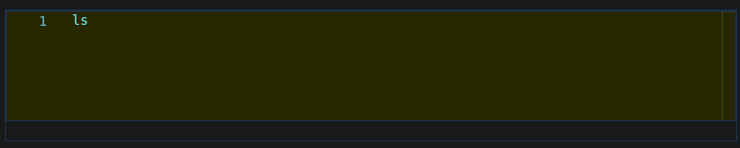
The temp directory should no longer be listed:
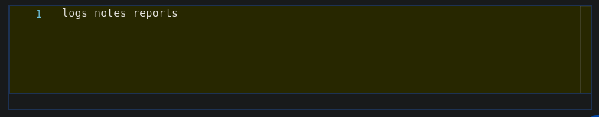

Task 3. Move a file
The Q3patches.txt file contains notes taken on third-quarter patches and is now in the correct reporting format.
You must move the Q3patches.txt file from the notes directory to the reports directory.
- Navigate to the /home/analyst/notes directory.
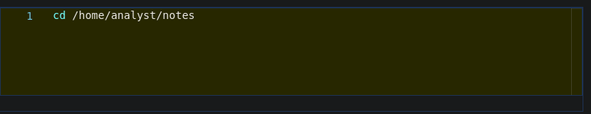
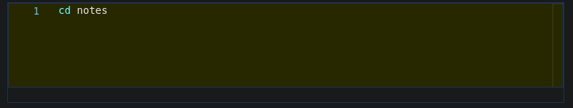
The command to complete this step:
The previous command used the absolute path, you could use the relative path as follows:
2. Move the Q3patches.txt file from the /home/analyst/notes directory to the /home/analyst/reports directory.
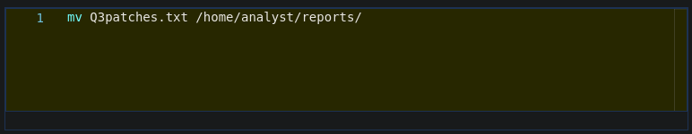
The command to complete this step:
3. List the contents of the /home/analyst/reports directory to confirm that you have moved the file successfully.
The command to complete this step:
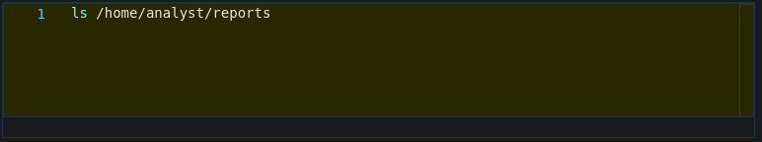

When you list the contents of the reports directory, it should show that three quarterly report files are now in the reports directory:

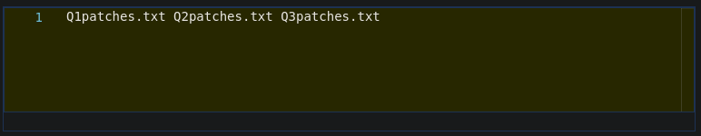
Task 4. Remove a file
Next, you must delete an unused file called tempnotes.txt from the /home/analyst/notes directory.
- Remove the tempnotes.txt file from the /home/analyst/notes directory.
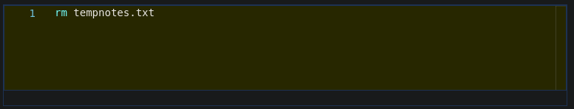
The command to complete this step:
2. List the contents of the /home/analyst/notes directory to confirm that you’ve removed the file successfully.
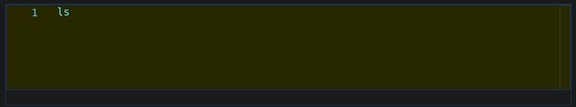
The command to complete this step:

Task 5. Create a new file
Now, you must create a file named tasks.txt in the /home/analyst/notes directory that you’ll use to document completed tasks.
- Use the touch command to create an empty file called tasks.txt in the /home/analyst/notes directory.
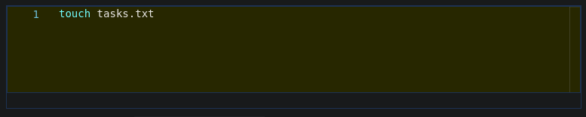
The command to complete this step:
2. List the contents of the /home/analyst/notes directory to confirm that you have created a new file.
The command to complete this step:
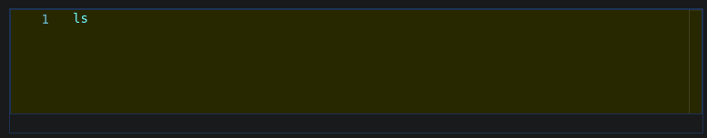
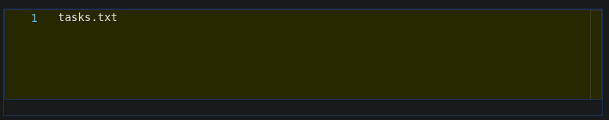
A file called tasks.txt should now exist in the notes directory:
Task 6. Edit a file
Finally, you must use the nano text editor to edit the tasks.txt file and add a note describing the tasks you’ve completed.
- Using the nano text editor, open the tasks.txt file that is located in the /home/analyst/notes directory.
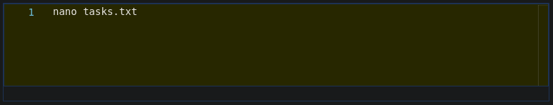
The command to complete this step:
Note: This action changes the shell from the normal Bash interface to the nano text editor interface.
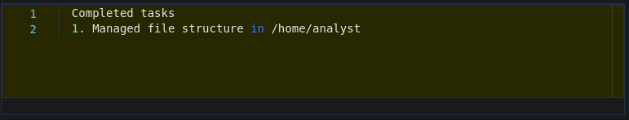
2. Copy and paste the following text into the text input area of the nano editor:

3. Press CTRL+X to exit the nano text editor.
This triggers a prompt asking Save modified bufferer?
4. Press Y to confirm that you want to save the new data to your file. (Answering "no" will discard changes.)
5. Press ENTER to confirm that File Name to Write is tasks.txt.
Note: The recommended sequence of commands for saving a file with the nano text editor is to use CTRL+O to tell nano to save the file and then use CTRL+X to exit immediately.
In this web-based lab environment, the CTRL+O command is intercepted by your web browser and is interpreted as a request to save the web page. The sequence used here is a commonly used alternative that achieves the same end result.
6. Use the clear command to clear the Bash shell window and remove any traces of the nano text input area.
The command to complete this step:
Note: Most Bash shells typically handle the screen cleanup after you exit nano. In this lab environment, nano sometimes leaves some text clutter around the edges of the screen that the clear command cleans up for you.
7. Display the contents of the tasks.txt file to confirm that it contains the updated task details.
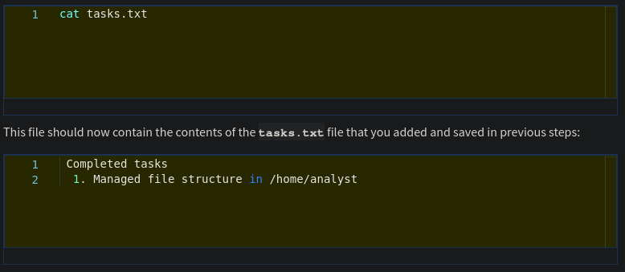
Conclusion
You now have practical experience in using basic Linux Bash shell commands to
- create and remove directories,
- copy, move, and remove files, and
- edit files with the nano text editor.
You’re well on your way to managing directories and files in a Linux environment!

